**PROBLEM STATEMENT**

**AI Based Discourse For Banking Industry**

In this project, we will be building a chatbot using Watson's assistant. This chat should have the following capabilities:

* The Bot should be able to guide a customer to create a bank account.
* The Bot should be able to answer loan queries.
* The Bot should be able to answer general banking queries.
* The Bot should be able to answer queries regarding net banking.

**Services Used:**

IBM Watson Assistant

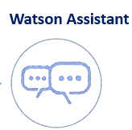

**Technical Architecture:**

